**Objective –**

Write a program to implement Insertion Sort.

**Description –**

**Insertion sort -**

* Insertion sort is a simple sorting algorithm that works the way we sort playing cards in our hands.
* This is an in-place comparison-based sorting algorithm. Here, a sub-list is maintained which is always sorted. For example, the lower part of an array is maintained to be sorted. An element which is to be 'insert'ed in this sorted sub-list, has to find its appropriate place and then it has to be inserted there. Hence the name, **insertion sort**.
* The array is searched sequentially and unsorted items are moved and inserted into the sorted sub-list (in the same array). This algorithm is not suitable for large data sets as its average and worst case complexity are of Ο(n2), where **n** is the number of items.

### **Algorithm**

Now we have a bigger picture of how this sorting technique works, so we can derive simple steps by which we can achieve insertion sort.

**Step 1** − If it is the first element, it is already sorted. return 1;

**Step 2** − Pick next element

**Step 3** − Compare with all elements in the sorted sub-list

**Step 4** − Shift all the elements in the sorted sub-list that is greater than the

value to be sorted

**Step 5** − Insert the value

**Step 6** − Repeat until list is sorted

Program –

#include<stdio.h>

#include<conio.h> //pre-processor directives

/* utility function to sort elements in ascending order */

void insertionsort(int x[],int n)

{

int i,j,val;

for(i=0;i<n-1;i++) // for loop

{ // useful code for shell sort with few changes

val = x[i+1];

for(j=i;j>=0;j--)

if(val < x[j]) // if statement

x[j+1] = x[j];

else // else statement

break; // break statement

x[j+1] = val;

}

}

/* starting point of the program */

int main(void)

{

int x[20],i,n;

clrscr();

printf("\n\t Enter the number of elements=");

scanf("\n\t%d", &n);

printf("\n\t Enter the elements\n\t");

for(i=0;i<n;i++)

scanf("\t%d",&x[i]);

insertionsort(x,n); //function calling

printf("\n\t -- Sorted Array -- \n\t");

for(i=0;i<n;i++)

printf(" %d ", x[i]);

getch();

}

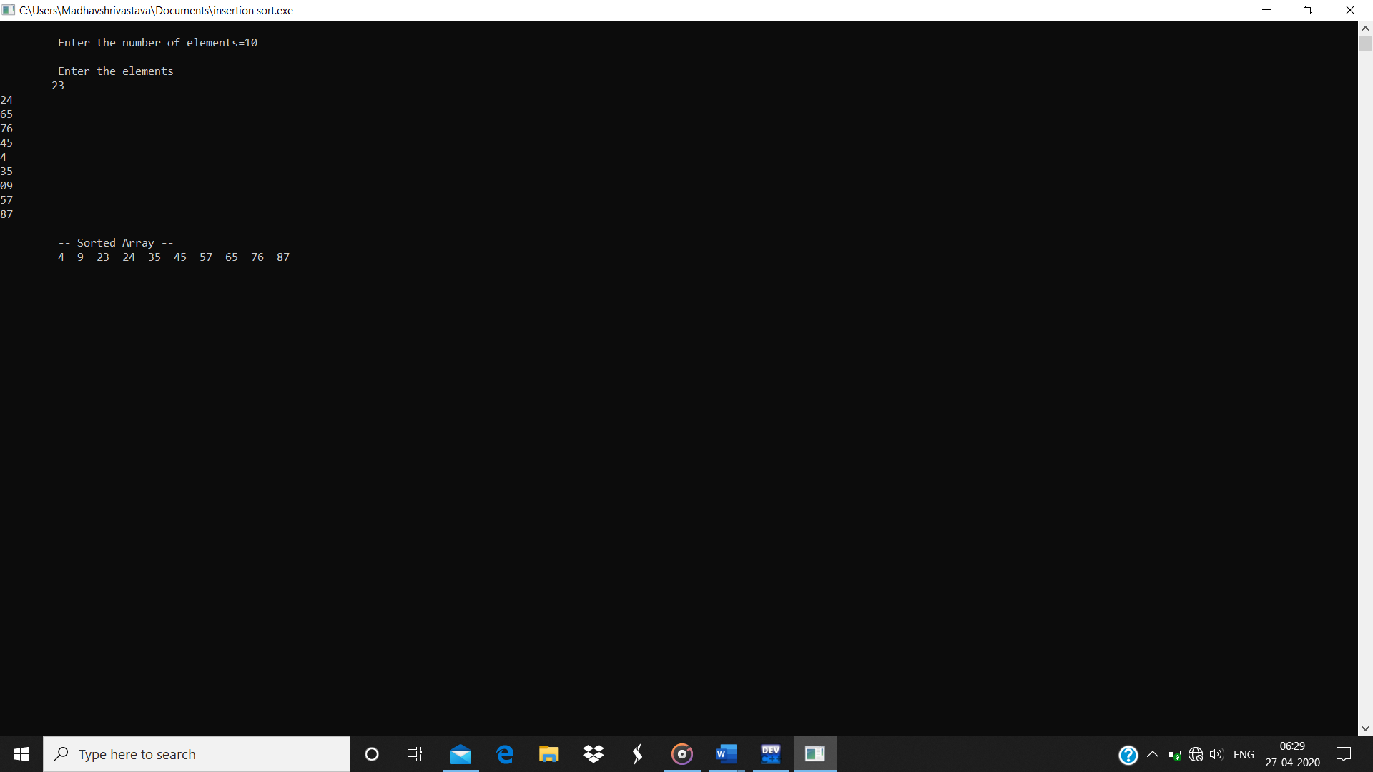Output-